1. Download the Lisp routine from share point.

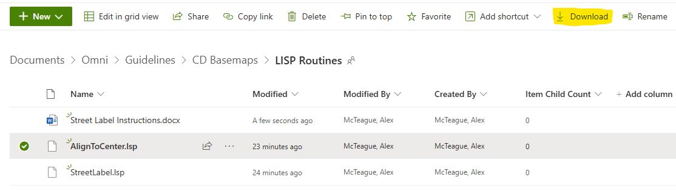

1. Use command APPLOAD to load the lisp routine

1. Make sure the file successfully uploaded. This is in the bottom left corner of the window.



1. Type in the command ALIGNTOCENTER



1. Select the first EOP

1. Select the second EOP

1. Select the Centerline

1. The Centerline should now be centered between EOPs, at every vertex

1. In some spots the Centerline may not seem “smooth” because there aren’t enough vertexes. In that case you can just add more vertexes and run the routine again

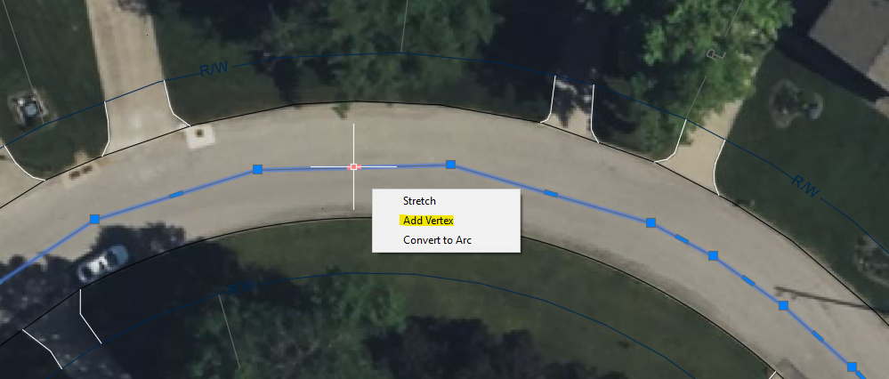

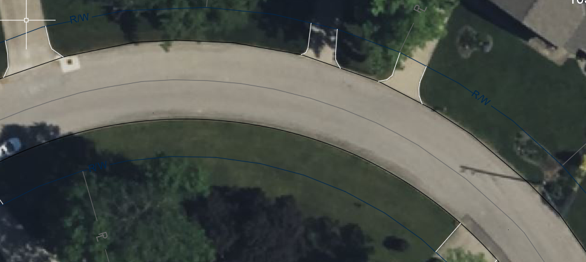

1. Make sure to adjust the endpoints of the centerline

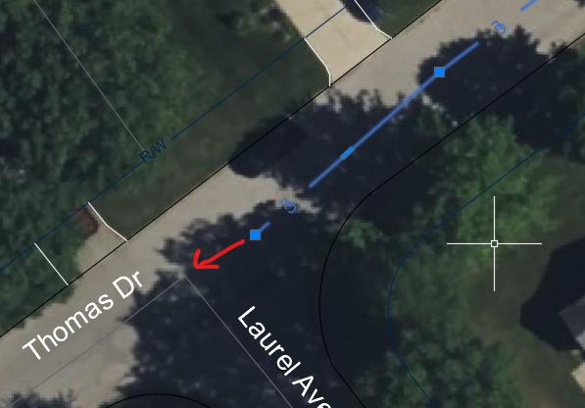

1. If the EOPs are part of the same polyline, you will have to temporarily break the line by using the BREAKATPOINT command

